PROGRAM 4.3. An applet program to get information from HTML file as a parameter.

*import java.applet.Applet;*

*import java.awt.Graphics;*

*public class useparam extends Applet*

*{*

*public void paint(Graphics g)*

*{*

*String str=getParameter("msg");*

*g.drawString(str,50,50);*

*}*

*}*

*<html>*

*<body>*

*<applet code="useparam.class" width="500" height="500">*

*<param name="msg" value="Welcome to Applet">*

*</applet>*

*</body>*

*</html>*

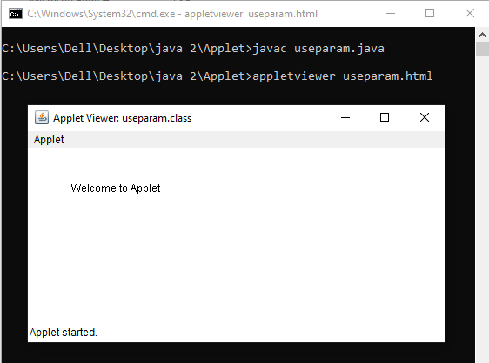

**EXPERIMENT: 2**

**1.TITLE:**

A java program of event handling.

**2.OBJECTIVE:**

1. To implement various listener interface.
2. To demonstrate and use adapter class.
3. To add listener in applets.

**3.THEORY:**

Event Handling is the mechanism that controls the event and decides what should happen if an event occurs. This mechanism has the code which is known as event handler that is executed when an event occurs. Java uses the delegation Event Model(DEM) to handle the events. For implementing event listener import java.awt.event.*; is imported.There are various event class provided by java. Some of them are:

3.1.ActionEvent- Actionlistener

3.2.KeyEvent- KeyListener

3.3.MouseEvent- MouseListener

3.4.MouseMotionEvent- MouseMotionListener

3.5.WindowEvent- WindowListener

**4.IMPLEMENTATION:**

**4.1.** Program to implement various listener interface.

**PROGRAM 4.1.1.**To implement keylistener.

*import javax.swing.*;*

*import java.awt.*;*

*import java.awt.event.*;*

*class keylistener implements KeyListener*

*{*

*JFrame j;*

*JTextArea a;*

*keylistener(){*

*j=new JFrame("Key Listener");*

*j.setSize(600,600);*

*a=new JTextArea();*

*a.setSize(200,200);*

*j.add(a);*

*a.addKeyListener(this);*

*j.setLayout(null);*

*j.setVisible(true);*

*}*

*public void keyPressed(KeyEvent e)*

*{*

*System.out.println("Key pressed");*

*}*

*public void keyTyped(KeyEvent e)*

*{*

*System.out.println("key typed");*

*}*

*public void keyReleased(KeyEvent e)*

*{*

*System.out.println("Key released");*

*}*

*public static void main(String args[])*

*{*

*new keylistener();*

*}*

*}*

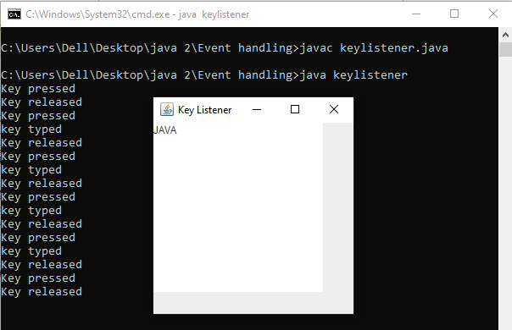OUTPUT:

**PROGRAM 4.1.2.** To implement MouseListener and MouseMotionListener.

*import javax.swing.*;*

*import java.awt.*;*

*import java.awt.event.*;*

*class mouselistener implements MouseListener,MouseMotionListener*

*{*

*JFrame j;*

*mouselistener(){*

*j=new JFrame("Mouse Listener");*

*j.setSize(600,600);*

*j.addMouseListener(this);*

*j.addMouseMotionListener(this);*

*j.setVisible(true);*

*j.setLayout(null);*

*}*

*public void mouseEntered(MouseEvent e)*

*{*

*System.out.println("Mouse entered");*

*}*

*public void mouseExited(MouseEvent e)*

*{*

*System.out.println("Mouse exited");*

*}*

*public void mouseClicked(MouseEvent e)*

*{*

*System.out.println("Mouse clicked");*

*}*

*public void mousePressed(MouseEvent e)*

*{*

*System.out.println("Mouse clicked");*

*}*

*public void mouseReleased(MouseEvent e)*

*{*

*System.out.println("Mouse released");*

*}*

*public void mouseMoved(MouseEvent e)*

*{*

*System.out.println("Mouse moved");*

*}*

*public void mouseDragged(MouseEvent e)*

*{*

*System.out.println("Mouse dragged");*

*}*

*public static void main(String args[])*

*{*

*new mouselistener();*

*}*

*}*

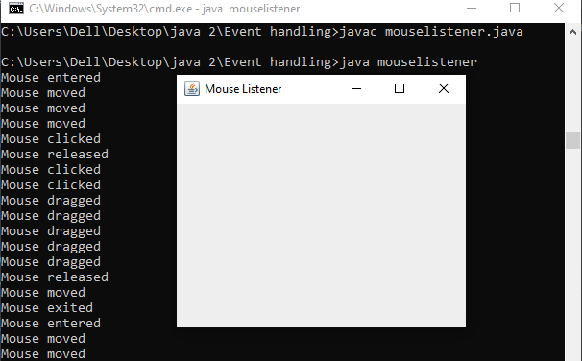

**PROGRAM 4.1.3.** To implement WindowListener.

*import java.awt.*;*

*import java.awt.event.*;*

*import javax.swing.*;*

*public class windowlistener implements WindowListener*

*{*

*JFrame j;*

*windowlistener()*

*{*

*j=new JFrame("window listener");*

*j.setSize(600,600);*

*j.addWindowListener(this);*

*j.setVisible(true);*

*// j.setLayout(null);*

*}*

*public void windowOpened(WindowEvent e)*

*{*

*System.out.println("Window opened");*

*}*

*public void windowClosed(WindowEvent e)*

*{*

*System.out.println("Window closed");*

*}*

*public void windowActivated(WindowEvent e)*

*{*

*System.out.println("Window activated");*

*}*

*public void windowDeactivated(WindowEvent e)*

*{*

*System.out.println("Window deactivated");*

*}*

*public void windowClosing(WindowEvent e) {*

*System.out.println("Window closing");*

*}*

*public void windowIconified(WindowEvent e)*

*{*

*System.out.println("Window iconified");*

*}*

*public void windowDeiconified(WindowEvent e){*

*System.out.println("Window deiconified");*

*}*

*public static void main(String args[])*

*{*

*new windowlistener();*

*}*

*}*

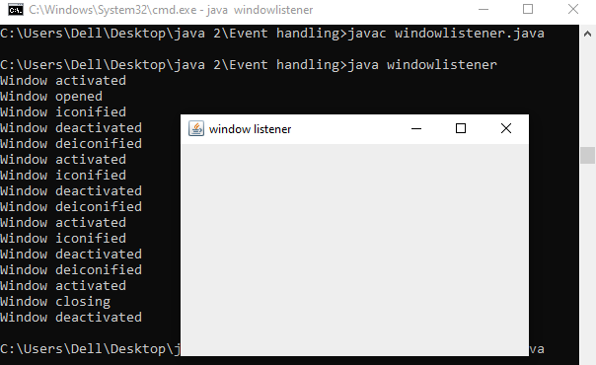

**PROGRAM 4.1.4.** To implement ActionListener.

*import java.awt.*;*

*import java.awt.event.*;*

*class actionlistener implements ActionListener*

*{*

*Frame f;*

*Button b1,b2;*

*Label l1,l2;*

*actionlistener()*

*{*

*f=new Frame("Action listener");*

*f.setSize(500,500);*

*b1=new Button("Button 1");*

*b1.setBounds(100,100,80,20);*

*f.add(b1);*

*b1.addActionListener(this);*

*b2=new Button("Button 2");*

*b2.setBounds(100,140,80,20);*

*f.add(b2);*

*b2.addActionListener(this);*

*l1=new Label("you clicked b1");*

*l1.setBounds(200,100,180,20);*

*f.add(l1);*

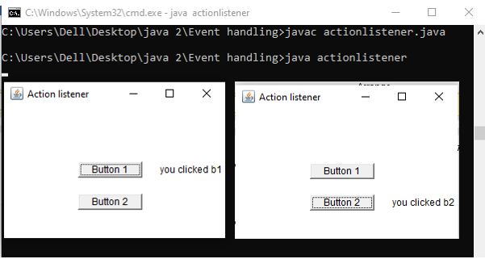 *l2=new Label("you clicked b2");*

*l2.setBounds(200,140,180,20);*

*f.add(l2);*

*f.setLayout(null);*

*f.setVisible(true);*

*}*

*public void actionPerformed(ActionEvent e)*

*{*

*if(e.getSource()==b1)*

*{*

*f.remove(l2);*

*f.add(l1);*

*}*

*else if(e.getSource()==b2)*

*{*

*f.remove(l1);*

*f.add(l2);*

*}*

*}*

*public static void main(String args[])*

*{*

*new actionlistener();*

*}*

*}*

**4.2.** Program to implement various listener adapter.

**PROGRAM 4.2.1**.To implement keylistener adapter.

*import java.awt.event.*;*

*import java.security.Key;*

*import java.awt.*;*

*class keyadapter{*

*Frame f;*

*keyadapter()*

*{*

*f=new Frame("Key adapter");*

*f.setSize(500,500);*

*f.addKeyListener(new KeyAdapter()*

*{*

*public void keyPressed(KeyEvent e)*

*{*

*System.out.println("Key Pressed");*

*}*

*});*

*f.setVisible(true);*

*f.setLayout(null);*

*}*

*public static void main(String args[])*

*{*

*new keyadapter();*

*}*

*}*

OUTPUT:

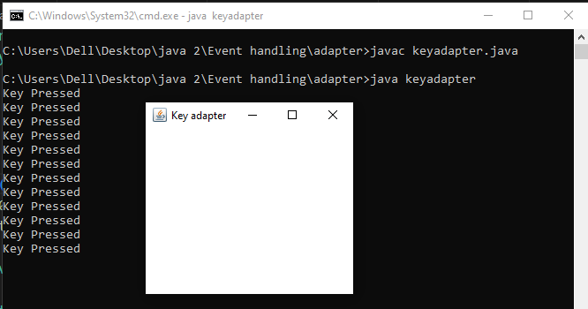

**PROGRAM 4.2.2.** To implement MouseListener,MouseMotionListener adapter.

*import java.awt.event.*;*

*import java.awt.*;*

*class mouseadapter*

*{*

*Frame f;*

*int i;*

*mouseadapter()*

*{*

*f=new Frame("mouse adapter");*

*f.setSize(500,500);*

*f.addMouseListener(new MouseAdapter()*

*{*

*public void mouseClicked(MouseEvent e)*

*{*

*i++;*

*System.out.println("Mouse clicked");*

*System.out.println("You clicked "+i+" times");*

*}*

*});*

*f.setVisible(true);*

*f.setLayout(null);*

*}*

*public static void main(String args[])*

*{*

*new mouseadapter();*

*}*

*}*

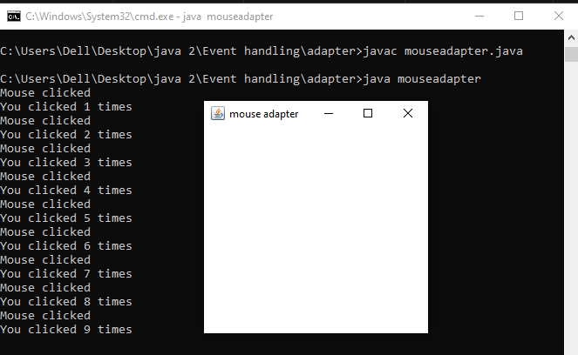

**PROGRAM 4.2.3.** To implement WindowListener.

*import java.awt.event.*;*

*import java.awt.*;*

*class windowadapter{*

*Frame f;*

*windowadapter()*

*{*

*f=new Frame("Window adapter");*

*f.setSize(500,500);*

*f.addWindowListener(new WindowAdapter()*

*{*

*public void windowActivated(WindowEvent e)*

*{*

*System.out.println("Window Activated");*

*}*

*});*

*f.setVisible(true);*

*f.setLayout(null);*

*}*

*public static void main(String args[])*

*{*

*new windowadapter();*

*}*

*}*

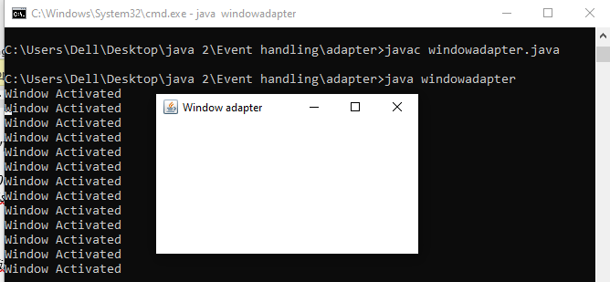

**4.3**. Program to implement various listener adapter in applet.

**PROGRAM 4.3.1**.To implement keylistener adapter in applet.

*import java.awt.*;*

*import java.awt.event.*;*

*import java.applet.*;*

*public class keylistenerapp extends Applet implements KeyListener*

*{*

*public void init()*

*{*

*addKeyListener(this);*

*setLayout(null);*

*}*

*public void keyPressed(KeyEvent e)*

*{*

*System.out.println("Key pressed");*

*}*

*public void keyTyped(KeyEvent e)*

*{*

*System.out.println("key typed");*

*}*

*public void keyReleased(KeyEvent e)*

*{*

*System.out.println("Key released");*

*}*

*}*

*/*<applet code="keylistenerapp" width="300" height="300"></applet> */*

OUTPUT:

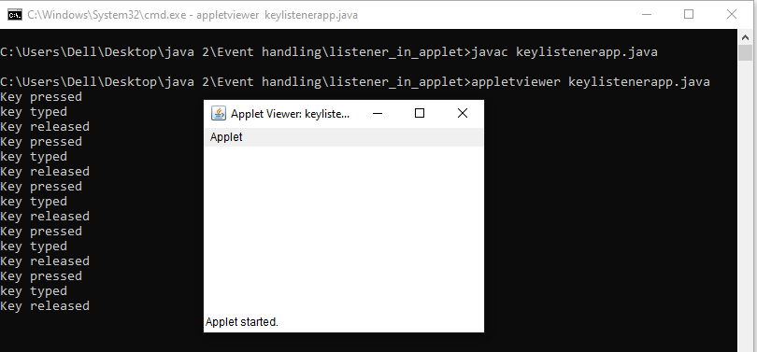

**PROGRAM 4.3.2.** To implement MouseListener and MouseMotionListener in applet.

*import java.awt.*;*

*import java.awt.event.*;*

*import java.applet.*;*

*public class mouselistenerapp extends Applet implements MouseListener,MouseMotionListener*

*{*

*public void init()*

*{*

*addMouseListener(this);*

*addMouseMotionListener(this);*

*setLayout(null);*

*}*

*public void mouseEntered(MouseEvent e)*

*{*

*System.out.println("Mouse entered");*

*}*

*public void mouseExited(MouseEvent e)*

*{*

*System.out.println("Mouse exited");*

*}*

*public void mouseClicked(MouseEvent e)*

*{*

*System.out.println("Mouse clicked");*

*}*

*public void mousePressed(MouseEvent e)*

*{*

*System.out.println("Mouse Pressed");*

*}*

*public void mouseReleased(MouseEvent e)*

*{*

*System.out.println("Mouse released");*

*}*

*public void mouseMoved(MouseEvent e)*

*{*

*System.out.println("Mouse moved");*

*}*

*public void mouseDragged(MouseEvent e)*

*{*

*System.out.println("Mouse dragged");*

*}*

*}*

*/*<applet code="mouselistenerapp" width="300" height="300"></applet> */*

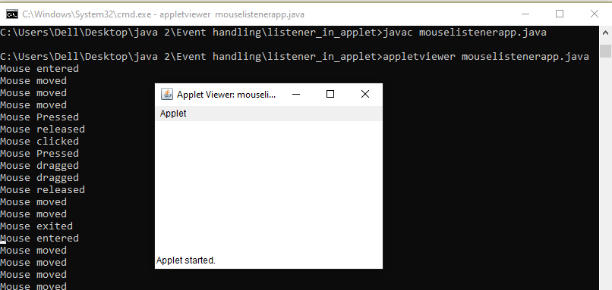

**PROGRAM 4.3.2.**To implement actionlistener in applet.

*import java.applet.*;*

*import java.awt.*;*

*import java.awt.event.*;*

*/*<applet code="actionlistenerapp" width="300" height="300"></applet> */*

*public class actionlistenerapp extends Applet implements ActionListener{*

*Button b;*

*TextField tf;*

*public void init()*

*{*

*tf=new TextField();*

*tf.setBounds(30,40,150,20);*

*b=new Button("Click");*

*b.setBounds(80,150,60,50);*

*add(tf);*

*add(b);*

*b.addActionListener(this);*

*setLayout(null);*

*}*

*public void actionPerformed(ActionEvent e)*

*{*

*tf.setText("Welcome to the World");*

*}*

*}*

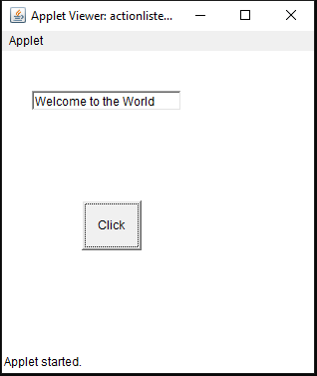

**5. OUTPUT AND DISCUSSION:**

In the Program 4.1 various listener interface are implemented importing awt. In the program 4.2, various listener interfaces are implemented using Adapter. In the program 4.3 various listener interfacess are implemented using Applet.

**6. CONCLUSION:**

Various event handling programs were compiled and executed successfully.